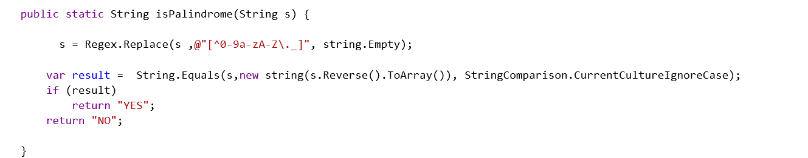

TEST1

using System;

using System.Collections.Generic;

using System.IO;

using System.Linq;

using System.Text.RegularExpressions;

namespace Solution {

class Solution {

public static void Main(string[] args) {

System.Console.WriteLine(isPalindrome(System.Console.ReadLine()));

}

public static String isPalindrome(String s) {

s = Regex.Replace(s ,@"[^0-9a-zA-Z\._]", string.Empty);

var result = String.Equals(s,new string(s.Reverse().ToArray()), StringComparison.CurrentCultureIgnoreCase);

if (result)

return "YES";

return "NO";

}

}

}

**TEST 2**

using System;

using System.Collections;

using System.Collections.Generic;

using System.IO;

using System.Linq;

using System.Reflection;

namespace Solution {

public class Test {

public class NavigationItem {

public String url;

public String label;

public List<NavigationItem> children = new List<NavigationItem>();

}

public static NavigationItem Root = new NavigationItem() {

label = "Root",

url = "http://foo.com",

children = new List<NavigationItem> {

new NavigationItem {

label="Products",

url = "http://foo.com/products",

children = new List<NavigationItem> {

new NavigationItem { label="Payment API", url = "http://foo.com/products/payment-api" },

new NavigationItem { label="Real-time Card Processing", url = "http://foo.com/products/real-time-card-processing" }

}

},

new NavigationItem {

label="Services",

url = "http://foo.com/services",

children = new List<NavigationItem> {

new NavigationItem { label="Payment Distribution", url = "http://foo.com/services/payment-distribution" }

}

},

new NavigationItem {

label="Contact Us",

url = "http://foo.com/contact",

children = new List<NavigationItem> {

new NavigationItem {

label="Sales",

url = "http://foo.com/contact/sales",

children = new List<NavigationItem> {

new NavigationItem { label="North America", url = "http://foo.com/contact/sales/na" },

new NavigationItem { label="Canada", url = "http://foo.com/contact/sales/ca", },

new NavigationItem { label="Europe", url = "http://foo.com/contact/eu" }

}

},

new NavigationItem { label="Legal", url = "http://foo.com/legal" },

new NavigationItem { label="Customer Service", url = "http://foo.com/customer-service" }

}

}

}

};

public static void Print(NavigationItem navItem) {

DisplayTree(navItem,0);

}

public static void DisplayTree(object navItem, int indent)

{

if (navItem == null) return;

string indentString = new string(' ',indent);

Type objtype = navItem.GetType();

PropertyInfo[] properties = objtype.GetProperties();

foreach (PropertyInfo property in properties)

{

object propvalue = property.GetValue(navItem,null);

var elems = propvalue as IList;

if(elems !=null)

{

foreach(var item in elems)

{

DisplayTree(item, indent + 3);

}

}

else

{

if(property.PropertyType.Assembly == objtype.Assembly)

{

Console.WriteLine("{0}{1}:", indentString,property.Name);

DisplayTree(propvalue, indent + 2);

}

else

{

Console.WriteLine("{0}{1}: {2}", indentString,property.Name, propvalue);

}

}

}

}

public static void Main(string[] args) => Print(navItem: Root);

}

}